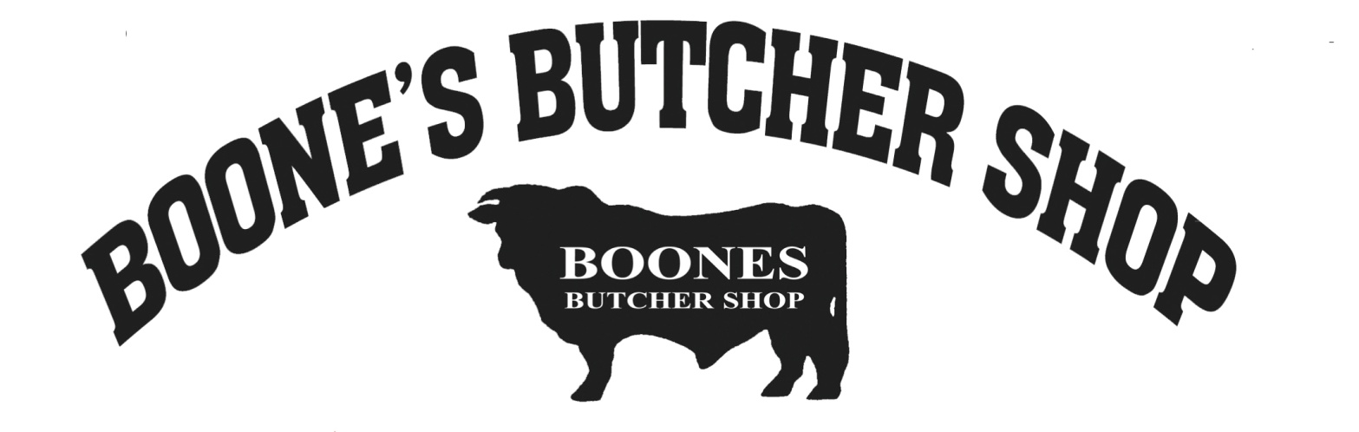
Boone’s Butcher Shop
100 Old Bloomfield Pike
Bardstown, KY 40004
(502) 348-3668

Job Description
Store Clerk

Description
Boone’s Butcher Shop is a family owned and operated retail meat store, slaughterhouse, and custom processing facility that has been operating for over 75 years. We pride ourselves in offering a wide selection of quality products and services and are looking for motivated individuals who are looking to improve or develop new skills and grow within our company. We have full time and part time positions with great hours and benefits.
Our butcher shop has an immediate need for a dedicated Store Clerk who can participate in sales and transactions on the floor, this is a customer service centered position. Hours can vary but are no later than 6:30 pm Monday through Friday, and no later than 3:30 on Saturday. Job requires long periods of standing and potentially lifting heavy items. Clerks may be required to work through holiday seasons and overtime.
Responsibilities:
- Operate the cash register and provide accurate change to cash-paying customers
- Preparing Deli Orders for Customers.
- Slicing/packaging Deli for case.
- Show customers the locations of items they are looking for and suggest complementary items when appropriate
- Greet customers when they walk through the door and ask if they need assistance
- Pay attention to shoppers on the floor and notify management of any possible shoplifting activity
- Restock shelves when needed to ensure optimum availability of products
- Unpack shipments in the store room and categorize them appropriately
- Place special orders for customers who can't find what they need in the store
- Prepare and distribute special-ordered merchandise
- Other duties as assigned
- Dependable: arrive on time, stay for full shift.
Qualifications:
- High school student or graduate preferred
- Excellent work ethic and time management skills
- Previous customer service experience a plus
- Strong interpersonal communication skills.
Job Type: Full-time
Salary: $10.00 to $11.00/hour
Work Remotely
- No
Job Types: Full-time, Part-time
Salary: $10.00 - $11.00 per hour
Benefits:
- 401(k)
- 401(k) matching
- Dental insurance
- Employee discount
- Health insurance
- Paid time off
- Vision insurance
Shift:
- 8 hour shift
- Day shift
Weekly day range:
- Monday to Friday
- Weekend availability
Education:
- High school or equivalent (Preferred)

