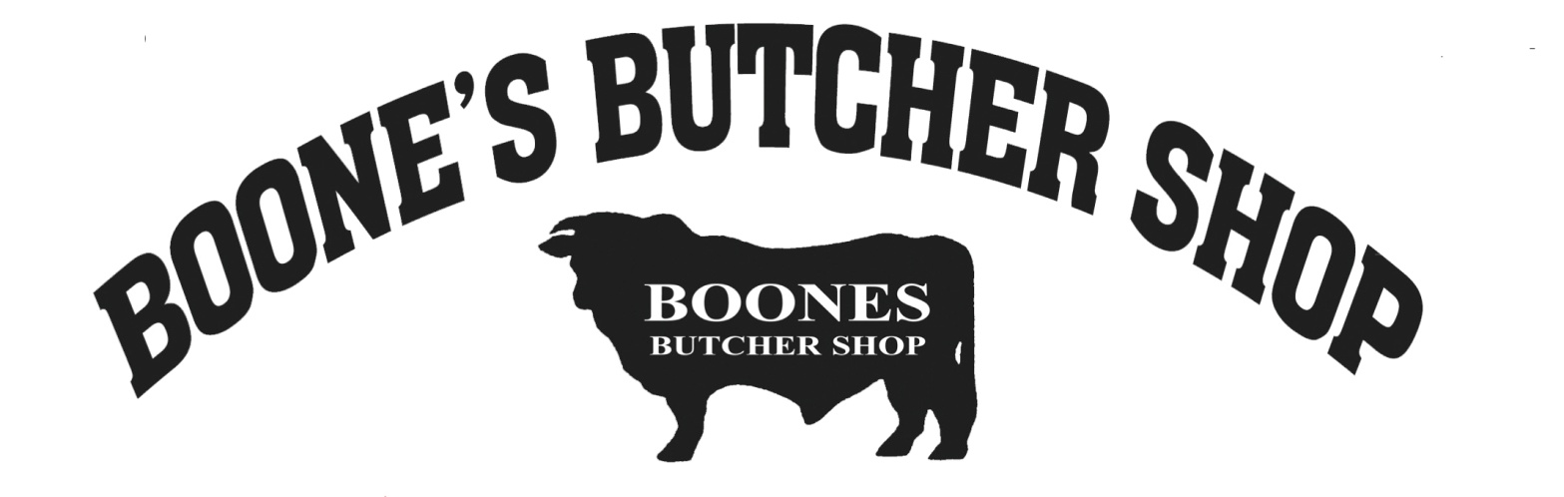
Boone’s Butcher Shop
100 Old Bloomfield Pike
Bardstown, KY 40004
(502) 348-3668

Job Description
Patty Associate
Boone’s Butcher Shop is a family owned and operated retail meat store, slaughterhouse, and custom processing facility that has been operating for over 75 years. We pride ourselves in offering a wide selection of quality products and services and are looking for motivated individuals who are looking to improve or develop new skills and grow within our company. We have full time and part time positions with great hours and benefits.

Description

Boone’s Butcher Shop is looking for a patty associate to run patties for the store, as well as for custom orders. Also responsible for assisting with load outs, cleaning and other store duties. This is a full-time/entry level position that requires long periods of standing and some interaction with customers. Hours are Monday – Friday 9am until all cleaning is completed (usually no later than 6:30pm), Saturday’s 8am until all cleaning is completed (usually no later than 4). You will have one day off through the week, and Sundays off except during peak season in November/December. Full-time employees qualify for benefits after waiting period: medical, vision, life, and dental insurance after 90 days (medical, vision & life are 100% employer paid). Supplemental, short/long term disability and holiday pay after 6 months. And 401K - with company match, and vacation accrual after 1 year. Bonuses & raises are assessed annually.

Responsibilities
- Use patty machine to make patties for store and for custom orders.
- Correctly identify size to be made and set up machine accordingly.
- Correctly label products made as well as accurate documentation of ground items.
- Meat bundles – package & label packages for meat bundles. Gather all product from freezers/coolers for our meat bundles when customers order them
- Load outs – Package and label packages for custom processing customers. Take product from freezer, box up and assist customers in loading product to vehicle.
- Clean, stock and supply designated facility areas (sweeping, mopping, cleaning ceiling vents, restroom cleaning etc.)
- Carry out heavy cleansing tasks and special projects (ex: Power washing floors, breaking down & cleaning machinery such as grinders)
- Notify management of occurring deficiencies or needs for repairs
- Other duties as assigned.

Qualifications
- Ability to lift 50 lbs. frequently overhead throughout the day required
- Experience as a cleaner preferred but not required
- Ability to handle heavy equipment and machinery
- Knowledge of cleaning chemicals and supplies preferred but not required – on site training provided

