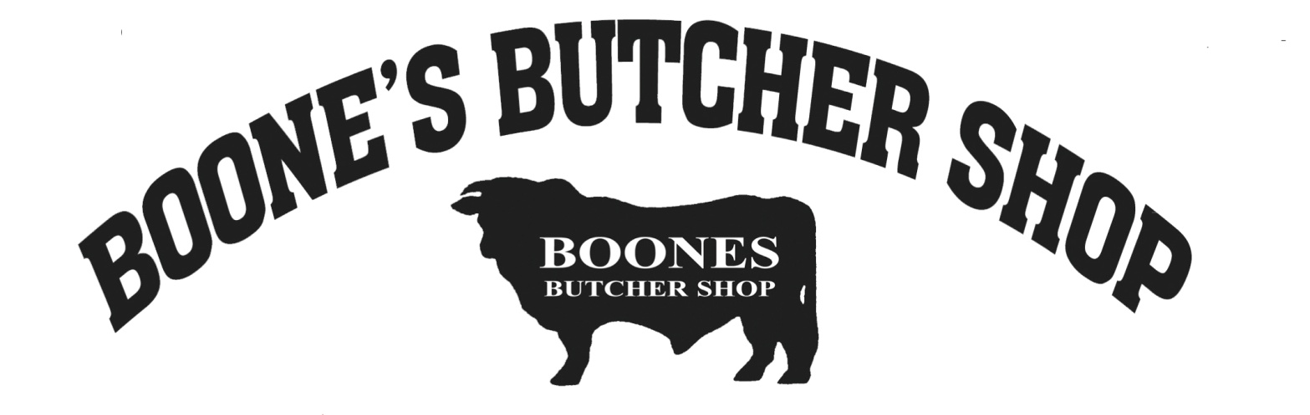
Boone’s Butcher Shop
100 Old Bloomfield Pike
Bardstown, KY 40004
(502) 348-3668

Job Description
Packaging Specialist

Description

Boone’s Butcher Shop is looking for a Packaging Specialist. The goal is to ensure all product is packaged and labelled properly. This is a full-time position that requires long periods of standing.

Responsibilities
- Package and label packages for custom processing customers and/or for store product
- Use large equipment for packaging
- Utilize computer software to track critical information for customer orders
- Make necessary adjustments and minor repairs to packaging and labeling equipment
- Notify management of occurring deficiencies or needs for repairs
- Carry out routine cleaning tasks and special projects
- Stock and maintain supply rooms
- Cooperate with the rest of the staff
- Follow all health and safety regulations
- Other duties as assigned.

Qualifications
- Knowledge of cuts of beef/pork preferred, but training will be provided
- Ability to handle heavy equipment and machinery
- Ability to lift 50 lbs. frequently throughout the day
- Integrity

Starting Pay: From $13.00/hr

